Alternative Solutions

# [Gameplay Time Tracker](http://www.gameplay-time-tracker.info/en/default.aspx)

## Summary

The [Gameplay Time Tracker](http://www.gameplay-time-tracker.info/en/default.aspx) does not have the following feature that are requested by the client:

* Produce detailed graphs on each program in the database
* Options to view a set time period, such as the week, month, day etc
* Track all processes by default
* Interface does not appeal to the client.

The following features are not wanted by the client, that are included in [Gameplay Time Tracker](http://www.gameplay-time-tracker.info/en/default.aspx):

* Primarily focused on games, with algorithms to detect only games.
  + It does not automatically detect windowed games (they can be added manually)
  + It does not detect DOS games
  + It does not detect games running within console emulators
* Game launcher, Client already uses Steam and Origin.

## 

## 

## Screenshots

The following screenshots show where the program falls short of the clients needs.

Only one graph is produced to show runtime vs date

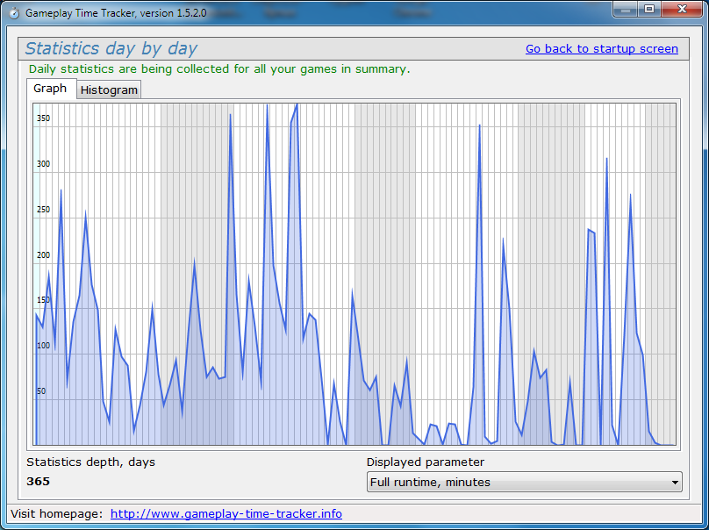

Focused on tracking Games rather than individual processes.

